The Value of Scripture Memory in Combating Destructive Behaviors

The Necessity of Memorizing Scripture
You will never fully grasp the necessity of memorizing Scripture until you understand that Jesus—in his humanity—retrieved the memorized Word as a means of victory over temptation. The writer of Hebrews reminds us, “He faced all of the same testings we do, yet he did not sin” (Heb. 4:14, NLT). Therefore, whatever temptations you face, the resources Jesus used are just as effective today. Jesus chose these resources:
- the Word of God
- the will of God,
- the love of God
- the glory of God.
The ability to retrieve memorized Scripture strengthens each of these resources.

The Word of God is our weapon. When the Devil tempted Jesus in the wilderness, Jesus did not argue, nor did he attempt to reason his way out of the challenge. He simply responded, “It is written” (Matt. 4:4, 7, 10). By answering with the truth of the memorized Word, Jesus repudiated the lies that the Devil was offering.

The Will of God is our purpose. Jesus modeled such a sweet spirit of submission in the Garden of Gethsemane. Under incredible emotional duress he responded, “not what I will, but what you will” (Mark 14:36). The battle with temptation is volitional. Sooner or later it attacks our will to choose. Jesus submitted his will to the Father.

The Love of God is our comfort. As Jesus draws nearer to the cross, he reflects more often on the way his heavenly Father loves him (John 15:9). He elevates this affirmation of the Father’s love over the circumstances he is facing.

The Glory of God is our intention. As Jesus nears his crucifixion, he cries, “Shall I say? ‘Father, save me from this hour’? But for this purpose, I have come to this hour. Father glorify your name” (John 12:27-28). When tempted, Jesus made his intention the Glory of God. When our desire for personal gratification surpasses our desire for the glory of God, we will be unable to stand against temptation.

A Paradigm for Memorizing Scripture
To expose temptation’s deceptions, we memorize verses in the lie/truth formula. To weaken temptation’s appeal, we learn promises about the character of God and the nature of the gospel.

How the lie/truth formula works
Because Satan’s temptations most often come in the form of deception, when we memorize the lies as well as the corresponding truth statement in the Scripture, we are far more prepared to handle the “Sword of the Spirit” when we’re tempted.

Examples:
Lie: God is keeping something good from you.
Truth: For a day in your courts is better than a thousand elsewhere. I would rather be a doorkeeper in the house of my God than dwell in the tents of wickedness. For the LORD God is a sun and shield; the LORD bestows favor and honor. No good thing does he withhold from those who walk uprightly (Psalm 84:10-12).

Lie: Your past is too bad. You can’t overcome it.
Truth: But one thing I do: forgetting what lies behind and straining forward to what lies ahead, I press on toward the goal for the prize of the upward call of God in Christ Jesus (Philippians 3:13-14).

Why the promise/passage formula is equally important
When we battle temptation as a child of God, we find that remembering God’s grace for us becomes a vital tool in weakening the appeal of the temptation. As we learn to love God more, we will love our sin less. For this reason, it’s equally important that we memorize truths about the character of God and the nature of the Gospel.

Examples:
Promise: God is God, loving and faithful.
Passage: The Lord is good; his steadfast love endures forever, and his faithfulness to all generations (Psalm 100:5).

Promise: God sacrificed his Son to show his love for me.
Passage: But God shows his love for us in that while we were still sinner, Christ died for us (Romans 5:8).

Why a balanced approach to Scripture memory is essential
One of the trademarks of Biblical Strategies, LLC is the balanced approach to Scripture memory. We recommend that the growing Christian alternate his/her Scripture memory plan between both formulas. In this way we become adept at seeing the deception of the temptation and we weaken the appeal of the temptation at the same time. Using this paradigm, Biblical Strategies has developed 20-card verse packs for a number of temptations including: anger, anxiety, procrastination, self-pity and sexual temptation and spiritual growth. (These are available at biblicalstrategies.com)

The Benefits of Memorizing Scripture

What others have said
God’s Word must become so strongly fixed in our minds that it becomes the dominant influence in our thoughts, our attitudes and our actions. – JERRY BRIDGES

I know of no other single practice in the Christian life more rewarding, practically speaking, then memorizing Scripture. No other single exercise pays greater dividends. Your prayer lire will be strengthened. Your witnessing will be more effective. You attitude and outlook will begin to change. Your mind will become alert and observant. Your confidence and assurance will be enhanced. Your faith will be solidified. – CHUCK SWINDOLL

Six reasons why Scripture memory is so essential: (1) conformity to Christ, (2) daily triumph over sin, (3) daily triumph over Satan, (4) comfort and counsel for people you love, (5) communicating the gospel to unbelievers, (6) communion with God in the enjoyment of his person and ways. – JOHN PIPER

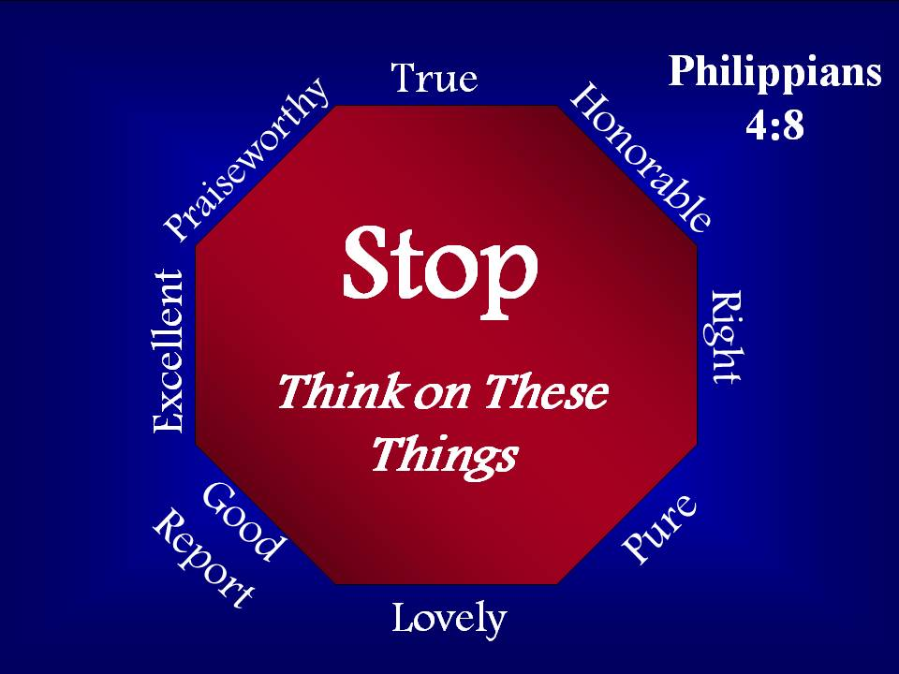
What others have testified
Twenty-five years ago, a deeply troubled young man stepped into my office. He was accompanied by a friend for the sake of encouragement. Together they began to pour out his sad story. When he was in 8th grade, he became a victim of sexual abuse by the hand of a high school teen. As he himself entered high school, he struggled with depression, attempted to take his own life, and was hospitalized. He had carried the dark secret alone. Neither parents nor counselors knew his past. Now, seven years later, his anxiety was all-consuming. His struggle with fear and worry had even crept into his sleeping hours, revealing itself through nightmares about the teen who had abused him.
I was fresh out of seminary with limited experience in the ministry. As I reached for my Bible, I remember praying to the Lord for guidance. I knew I was in way over my head.
I asked the young man what he was thinking about before he fell asleep. He acknowledged his painful past consumed his thoughts. He said, tearfully, “I’m just praying to God that the nightmares won’t come back.”
“I understand you’re praying, but what are you thinking about?”
“The nightmares,” he said, “I don’t know how to stop.” Together we opened up our Bibles to Philippians 4:8 and read, “Finally, brothers, whatever is true, whatever is honorable, whatever is just, whatever is pure, whatever is lovely, whatever is commendable, if there is any excellence, if there is anything worthy of praise, think about these things.”
“Your challenge,” I said, “will be to develop a plan where you think on the things that are in that list.” Together we read the promise that came next: "What you have learned and received and heard and seen in me — practice these things, and the God of peace will be with you."
“Memorizing is only the first part,” I added. “You’re actually going to have to do it.”
“Do what?” he said.
“Think on these things,” I replied.
Together we drew an octagon. He wrote each of the eight qualities found in the verse on the outside boarders of the sign. Inside the sign we wrote the words, “Stop! Think on these things.” On a separate piece of paper, he wrote each quality as the heading for a list. The eight lists would include anything he could think of that was “true, honorable, just, pure, lovely, commendable, excellent, and worthy of praise.”
One week later he returned to my office with his friend. The two sat down. I began the conversation. “How’s that Bible verse I asked you to memorize?” His friend smiled and shook his head as if he knew something I did not.
“Why the smile?” I asked.
“Did you want him to tell it to you forwards or backwards?”
“Let’s start with forwards.” I said. The young man quoted the verse perfectly, one word after the other.
“Can you really quote the verse backwards?” I asked incredulously. Phrase by phrase, he gave the verse backwards without missing a beat. “That’s pretty amazing” I said. “So how are the nightmares?
He looked me in the eyes, shrugged his shoulders, and smiled.
“What nightmares?”
Taken from Safe in the Storm: biblical strategies for overcoming anxiety

What Jesus did
Jesus heard the words before he saw the shape. “If you are the Son of God, command this stone to become bread.” Those words elicited his strongest hunger pains yet. His stomach insisted. His body quivered for lack of strength. The memory of his mother’s baking wafted up from the desert floor. The nerve endings in his fingertips sprung to life and fired the message: The stone beneath your hand feels like a loaf of bread. Just say the word. He paused briefly before he spoke. Remembering Eve’s failure with the deceiver, he didn’t want to engage a conversation; he wanted to parry with truth. His mind chased down the Biblical narratives he’d learned as a child. He was looking for parallels to his situation.
The wilderness. The desires of his people. The nagging hunger pains. He had the story. He could see the letters on the scroll. His mind raced to the final verse. He opened his mouth and spoke. “It is written, ‘Man shall not live by bread alone.’”
The written Word had authority. It emptied the deception of its power. In a moment the mirage of his mother’s oven was gone. His hunger subsided. And his fingertips told him the truth: The stone beneath your hand feels like . . . a stone.
The deceiver couldn’t argue. Still, he continued to circle. Perhaps it would be best if he came back at another time.
Taken from Just Like Jesus: biblical strategies for growing well

